**Canadian Mining in Africa and Latin America: A Comparison based on Mine Output and Asset Valuation**

Aniket Bhushan[1] and Pablo Heidrich

The North-South Institute

July 2013

**Introduction**

This background note is a working output from ongoing research at The North-South Institute (NSI). The aim of the project is to assess the economic impact of the overseas operations of Canadian mining firms. The project contributes to ongoing debates in Canada, Africa and Latin America regarding the direct economic effect of mining projects on communities and host countries in which they operate.

This paper provides a preliminary comparison of Canadian mining in Africa and Latin America, based on data collected and analyzed on NSI’s Canadian International Development Platform (CIDP).[2] The main aim of the paper is to obtain feedback on our preliminary findings, our approach and describe our data and methodology.

Mining is a key sector in the Canadian economy and Canada is a global mining giant. The mining industry’s contribution to the Canadian economy ranged from $40 billion to $35 billion a year or between 4 and 2 per cent of Canada’s gross domestic product (GDP) between 2005 and 2011. Globally, Canada is among the top 5 producers of key minerals including: Uranium, Cobalt, Aluminium, Titanium, Platinum, Tungsten, Sulphur, Diamonds and Nickel, and is the world’s largest producer of Potash (MAC 2012). Mining is one of the largest export sectors for Canada representing 23 per cent of total exports in 2011 (NRCAN 2011).

Canada’s global presence in mining goes well beyond trade. 70 per cent of the equity capital raised for mining globally in 2012 was raised on the Toronto Stock Exchange (TSX) and the Venture exchange (TSXV). Canadian exchanges are the largest source of mining financing in the world. Thanks to a highly mining friendly business climate, Canadian capital markets are especially attractive for small and medium sized mining companies. Of the $10.3 billion in equity raised for mining on the TSX and TSXV in 2012 $1.9 billion or 18.5 per cent was for projects in Latin America while another $1.7 billion or 16.5 percent was for projects in Africa.

**Mining from a Canadian policy perspective**

Recent changes to Canada’s foreign policy architecture have the potential to bring Canada’s approach to foreign aid, trade and investment closer together. The folding of the Canadian International Development Agency (CIDA) into the new Department for Foreign Affairs, Trade and Development offers the potential to raise the profile of international development in Canadian foreign policy (Bhushan and Ingram 2013).

Mining has become a focal point in each of these areas. In the area of aid policy, critics allege CIDA is “subsidizing” Canadian mining operations overseas by increasingly partnering with some of the largest Canadian mining companies, such as Barrick Gold and IAMGold, in connection with their corporate social responsibility initiatives. Proponents on the other hand argue such multi-stakeholder approaches involving aid agencies, non-governmental organizations (NGOs) and the private sector merely reflects the reality of the sort of partnerships needed to ensure mining investment has a net positive development impact. CIDA is also financing the creation of the Canadian International Institute for Extractive Industries and Development which aims to “mobilize Canadian and international expertise and practical experience in improving and strengthening extractive resource governance” (UBC 2013).

Beyond aid, the presence and interests of Canadian mining companies overseas is a key driver of Canada’s trade and investment policies towards developing countries. The large presence of Canadian mining in Latin America coincides with the proliferation of free trade agreements (FTAs) between Canada and key mining trade partners including Peru (2009), Colombia (2010), Honduras (2011) and Panama (2012), and other FTA negotiations with Central American countries. Mining interests are also clearly reflected in Canada’s foreign investment protection agreements (FIPAs) including with Mongolia, Indonesia, Vietnam, Kazakhstan and Tunisia. Negotiations with a significant mining component have recently been concluded with Tanzania, China and Senegal. Since 2006, Canada has concluded or brought into force FIPAs with 13 countries, and is in active negotiations with 13 others, many of which are African countries. Negotiations are underway in Zambia, Tunisia, Benin, Burkina Faso, Ghana, Côte d’Ivoire and Cameroon. Other recently concluded FIPA agreements with African countries include Madagascar, Mali and Senegal (MAC 2012).

**Our data and methodological approach**

While there are several widely used and high quality sources on Canadian mining,[3] there appear to be gaps when the primary interest is in the foreign operations of Canadian mining entities. Part of the challenge stems from the nature of the industry itself. Mining is a highly complex and multistage activity. Furthermore, most of the largest mining companies often operate via smaller subsidiaries or joint ventures.

In assembling our data we had to negotiate three key questions: what is a “Canadian” company or investment? At what stage should we make the assessment? And in calculating revenue yield which international prices should we use and how?

At this preliminary stage of the project we limited “Canadian” company or investment, in accordance with standard practice, to companies headquartered or based out of Canada. On the second question, as a start, we limited the stage to mines in production in a given year. Activities at the exploration, advanced exploration and other earlier stages were excluded for the moment. For international prices we referred to key sources for commodity prices such as the London Metals Exchange, World Gold Council, and International Monetary Fund and select others.[4] To smooth volatility we averaged out monthly prices based on the calendar year.[5]

At this preliminary stage our main interest is in providing an approximate valuation for the revenue yield, at the individual mine level. The total revenue estimate is calculated as: mine production per commodity X international price of the commodity in the production year. While this is a relatively simple approach it is very similar to international practice such as used in the Extractive Industries Transparency Initiative’s country reports and data. We aggregate up mine level data to the host country level, company level as well as by commodity. The next stage of the project will: bring into the picture costs associated with operations, extend the time-series, look at mining investments from Canadian firms at earlier stages, estimate tax contributions, assess local employment practices and contracting of local or national companies in host countries.

Data was gathered from the technical reports of each mine published online by their owning company, and the annual reports for those companies, complemented by additions from Infomine, a mining industry data portal. The former sources are freely available directly from the companies’ websites or downloadable from SEDAR (System for Electronic Document Analysis and Retrieval) from the Canadian Security Administrators. The latter source is from a paid subscription to Infomine, which lists all properties and companies with operations around the world. Infomine data was manually compiled and processed in order to match properties with owning firms. All data was geocoded with latitude and longitude to enable it to be mapped at actual locations (see geocoded maps below).

The discussion above describes our data and approach from a “mine output perspective”. We complement this with an “asset valuation perspective”. Data on asset valuation come from NRCAN’s Canadian Mining Assets Abroad (CMAA) dataset, provided to us directly. Asset valuation differs from both trade data as well as foreign direct investment (FDI) data. Mining assets are those associated with a company’s mining and mineral businesses segment non-current fixed assets. Assets are recorded geographically as accurately as possible based on data availability from company financial reports. Only investments in foreign mining companies are recorded, in order to avoid double counting. Values are converted to Canadian Dollars using the rates posted at the date of the financial report. CMAA estimates, as calculated by Natural Resources Canada, differ from the Canadian Direct Investment Abroad (CDIA) figures estimated by Statistics Canada. Mining asset valuation provides a good sense of Canada’s mining presence internationally, even though there may be limitations in terms of comparison with other data.

Asset valuation differs from FDI in a few key ways: FDI presumes financing comes from Canada while asset valuation does not. FDI considers both asset and liabilities while CMAA only considers assets. FDI data are based on first destination while CMAA is based on the final destination. For example Canadian investment destined for Mexico that goes through a U.S. subsidiary is counted as FDI in the United States. The same transaction in asset valuation terms would be counted in Mexico.

The asset valuation perspective provides a useful complement to the mine output approach described earlier. Next we turn to our findings for Africa and Latin America, starting with the mine output approach and concluding with asset valuation.

**Our findings**

*Number of mining properties and companies*

We estimate the number of producing Canadian owned mining properties in Latin America to be 80 in 2012 with an additional 22 coming online in 2013, while the number of producing mining properties in Africa to be 41, with 7 more coming online in 2013. This includes partially owned properties, and to the extent information was available, includes producing properties owned by subsidiaries. The number of Canadian companies producing in Latin America is 43, while the number of producing companies in Africa is 23. These figures are based on mining properties in production in 2012.

*Mining activity by stage and region*

Mines in production are a significant share of the overall picture in terms of economic impact but it is important to consider mines in other stages of development. The following chart shows the number of properties owned by Canadian companies in Latin America and Africa at various stages of development (Note: data was gathered from Infomine and other sources, and is as of June 2013).

The graph shows Latin America continues to be of greater interest to Canadian companies than Africa. Canadian presence in Latin America is larger than Canadian presence in Africa at all stages. The graph also provides a sense of the ratio between pre-production and production activity.

*Estimated total revenue yield*

The total estimated revenue yield calculated as total mine production X international price of the commodity in the given year, for all Canadian owned properties in production in Latin America in 2012 was $ 19.4 billion. The total revenue yield for Canadian owned producing properties in Africa in 2012 was $ 12.9 billion.

*Revenue yield by commodity, country and companies*

Gold, copper, silver and zinc were the main commodities produced in Latin America. Copper and gold account for the vast majority of production by Canadian owned mines in Africa.

The vast majority of Canadian company revenues, or about US$17.9 billion, accrues in 5 countries in Latin America: Mexico, Chile, Peru, Argentina, and Brazil. Six Canadian companies are dominant in terms of mining revenue from the region: Barrick Gold, Yamana Gold, Teck, Goldcorp, Kinross Gold, and Pan American Silver.

The largest producing Canadian companies in Africa were: First Quantum, Lundin Mining, New Dawn Mining, Franco-Nevada, IAM Gold, Kinross, Galane, Barrick Gold, Nevsun Resources, and Semafo. Zambia, DR Congo, Ghana, Zimbabwe and Burkina Faso were the most important countries for Canadian owned properties in production. While countries like Eritrea (gold) are also rapidly emerging.

In calculating revenue yield we made every effort to only use internationally accepted data sources for commodity prices. However the nature of some of the commodities makes this challenging. For instance in the case of diamonds, prices can be spread over a large range depending on various aspects of quality. This may affect revenue calculations for some countries in Africa (Botswana, South Africa, Namibia and Lesotho) where Canadian owned diamond producers are located. Our calculations like understate the actual revenue yield.

*Mining asset valuation perspective*

The total stock of Canadian mining assets abroad in 2011 was $ 215.3 billion. The vast majority of Canadian mining assets abroad are in Latin America, at $ 156 billion or 72%. Total Canadian mining assets in Africa in 2011 are estimated to be valued at $ 31.6 billion or around 14.6%. This data was provided to the researchers directly by Natural Resources Canada (NRCAN) and may not correspond entirely with the mine output perspective. However it does serve as a useful reference for the scale of Canadian operations in the two regions.

**Map of Canadian Mining Assets Abroad from an Asset Valuation Perspective (2011)**

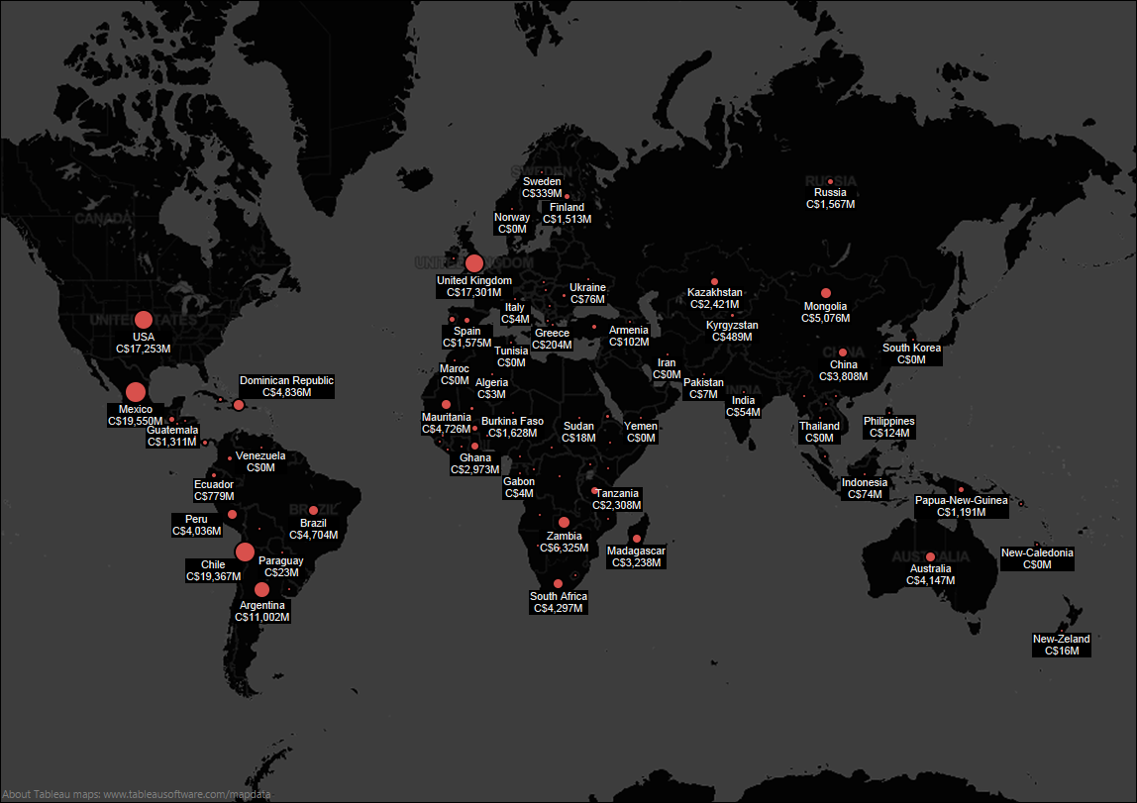

**Map of Canadian Mining in Latin America in 2012**

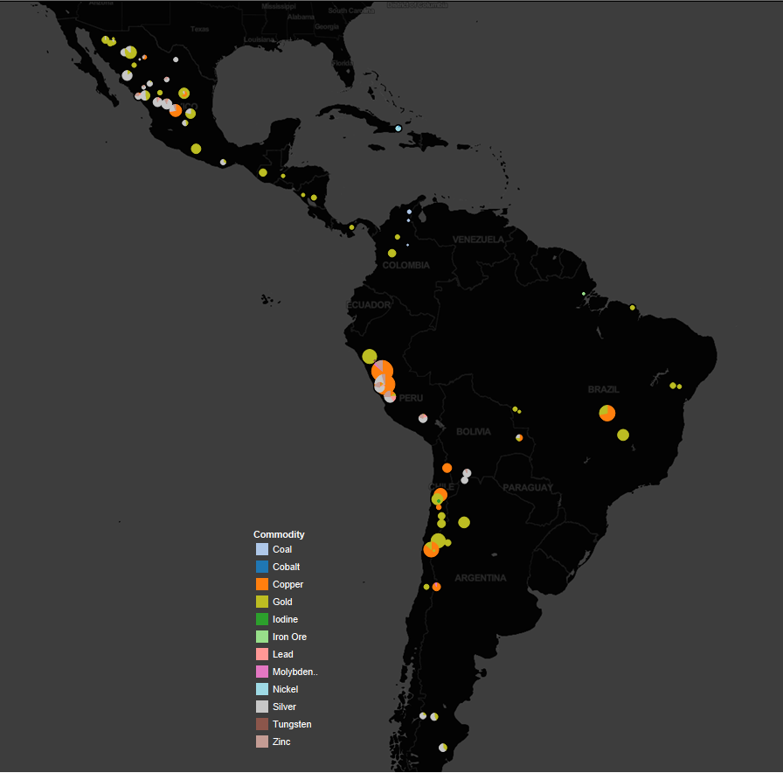

**Revenue Yield per Commodity by Country**



**Major Commodities Produced in Latin America (2012) by Revenue Yield**



**Main Companies Producing in Latin America (2012) by Revenue Yield**



**Map of Canadian Mining in Africa (producing entities in 2012 plotted)**



**Countries by Revenue Yield per Commodity**



**Major Commodities Produced in Africa (2012) by Revenue Yield**



**Main Companies Producing in Africa (2012) by Revenue Yield**

**References**

Bhushan, A., & Ingram, J. (2013). *CIDA Merger Should get Canada Thinking Bigger on Development*. Retrieved from North South Institute: <http://www.nsi-ins.ca/newsroom/cida-merger-should-get-canada-thinking-bigger-on-development/>

Mining Association of Canada. (2012). *Facts and Figures 2012*. Retrieved from: <http://www.mining.ca/www/media_lib/MAC_Documents/Publications/2013/Facts%20and%20Figures/FactsandFigures2012Eng.pdf>

NRCAN. (2013). *Key Mining Facts 2012*. Retrieved from NRCAN: <http://www.nrcan.gc.ca/minerals-metals/nmw-smc/4450>

UBC. (2013, 06 21). *The Canadian International Institute for Extractive Industries and Development*. Retrieved from UBC Faculty of Applied Science: <http://apsc.ubc.ca/apsc-eng/giving/faculty-priority-projects/ciieid>

1. **DRAFT NOT FOR CITATION**. For correspondence please use: [abhushan@nsi-ins.ca](mailto:abhushan@nsi-ins.ca) . We thank Matt Blundell and Nathan Bowers-Krishnan for research assistance.
2. CIDP is NSI’s interactive data and analysis platform on Canada’s engagement with the developing world. The aim of the CIDP is to engage Canadians on international development and elevate the quality of debate by grounding discussions in the best available evidence. See: <http://cidpnsi.ca/>
3. These include for instance these databases managed by Natural Resources Canada (NRCAN), the TRAGS database on trade in minerals, Statistics Canada, as well as Mining Association Canada’s annual Facts and Figures.
4. Prices dataset available upon request and will be updated in a forthcoming version of this paper.
5. The price per commodity therefore is the 12 month average for the calendar year. We have extended some of the data over time-series to cover multiple years but for most of the discussion here the reference year is 2012.